Setup spring boot Secret id and client

- Command

-----------------Setup Google id and secret​ ​temporary:

set GOOGLE_CLIENT_ID=637653487091-h4vjkc6vtd026glldbsg4riqs79d7dt5.apps.googleusercontent.com
set GOOGLE_CLIENT_SECRET=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

---------------Set permanently in Windows

setx GOOGLE_CLIENT_ID "your_google_client_id"
setx GOOGLE_CLIENT_SECRET "your_google_client_secret"
==>

setx GOOGLE_CLIENT_ID "637653487091-h4vjkc6vtd026glldbsg4riqs79d7dt5.apps.googleusercontent.com"

setx GOOGLE_CLIENT_SECRET "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"

-----------------Check the setup in Google

echo %GOOGLE_CLIENT_ID%
echo %GOOGLE_CLIENT_SECRET%

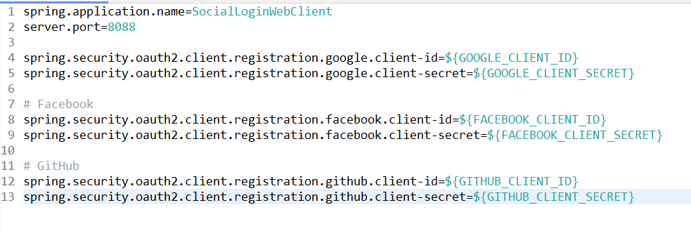

How to create from youtube:

link:

https://console.cloud.google.com/auth/clients?project=my-spring-test-app-489909

YouTube:
https://www.youtube.com/watch?v=D8DMj2lQMwo

- We use command to verify

